Nomination Form for  COLNE BID Board Director | 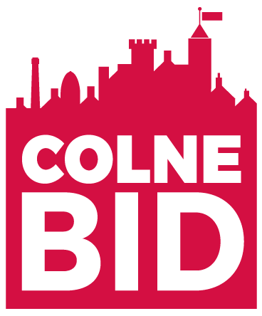

Electing the BID Board

In June 2018, businesses in Colne voted by almost 3 to 1 in favour of the proposal for a new Business Improvement District (BID). The BID proposal for October 2018 – September 2023 sets out a business plan to deliver on the priorities identified through consultations with business owners and managers across the town. The Proposal also states that Colne BID will be managed by a new not-for-profit BID Company, with its own ring-fenced accounts, and with membership open to nomination and election from all eligible BID levy-paying businesses, organisations and individuals.

The initial Board of Directors was set up in September 2019, comprising of 8 Directors. Colne BID has been carrying two vacancies since it set up. At the June 2019 BID Board meeting, it was agreed to recruit at least 2 new Directors and also to increase the BID Board by a further 2 Directors (12 in total), should there be interest from BID Members.

Nominations are invited from those eligible to become members of the new company. This includes all Colne BID levy payers.

To Apply, Membership registration forms will be available to download at www.colnebid.co.uk

The completion and submission of the Nomination Form cannot guarantee a seat on the Board of Directors. To ensure that a range of relevant sectors and skills are represented on the Board, candidates will need to set out their experience and their commitment to ensuring the success of the Colne BID.

If the number of nominees exceeds the proposed number of Directors’ seats, then a ballot may be held. This should only be necessary to select between candidates representing specific sectors where these are over-represented, for example, if 3 nominees are small businesses but there are just 2 seats for small businesses on the Board then a ballot will be held to select 2 Directors from the 3 candidates (refer below). Voting will be by registered members only and the result determined by simple majority. In the event of a tie, the decision will be deferred pending the appointment of the Chair of the Board who will carry the casting vote.

Purpose of the Board

The Colne BID Board will be composed of up to 12 Directors. It will be accountable for:
- Upholding and promoting the BID vision and objectives;
- Delivering the four priorities of the BID Proposal efficiently and effectively;
- Promoting the mutual and active support of businesses and partners.

This is a voluntary role, as none of the Directors will receive any remuneration. The Board is committed to meeting at least 4 times per year with meetings anticipated to last no more than two hours and held at times carefully planned to maximise attendance and minimise any inconvenience. Sub groups may meet more frequently, for example, to determine the detail of the marketing elements of the programme. Currently BID Board meetings are held on a Tuesday evening at 5.15pm -7.30pm, every 4-5 weeks.

Composition of the Board

The Colne BID Board will be composed of a cross-section of BID levy-paying businesses, organisations and individuals. We also want businesses represented from different areas of the Colne BID Area eg. We currently have no business on the board from the North Valley Road area. We are specifically looking to recruit a Large business /Retailer, one of the 3 theatres, another business from the food and drink sector and a community /charity organisation.

Ideally the elected Directors of the Board should represent the following:

Sectors (size) | Number of director posts | Distribution
Small business (typically local independents) | 2 | The BID Board should, where possible, seek membership from businesses across the BID area, representing different parts of Colne town centre.
Large business (typically national or regional) | 3
Professional & financial services | 2
Hospitality, food & drink | 2
Charitable (including non-commercial) | 1
Other sectors – Landlord /Property Developer | 1
Local authority (subject to invitation) | 1

In addition to the above, Board Directors may, at their discretion, agree to invite the following non-voting attendees:

- Persons with knowledge or information appropriate to the aims of the BID;
- Persons with professional or technical expertise to advise the Board on specific matters.

The rules governing the conduct of BID Company Directors will be set out in the Company’s Articles of Association – copies available on request by contacting Lisa Durkin, Colne BID Manager by email: manager@colnebid.co.uk

If you wish to stand for election to the Colne BID Board to fill the current vacancies, please complete the form below, providing the information requested and return it to the address below by 22 JULY 2019.

Completed forms should be returned to:
Stuart Wilson , Chair of Colne BID, Coversure Insurance, 50 Market St, Colne BB8 0HS
Or email the completed form to: manager@colnebid.co.uk

RETURN BY MONDAY 22 JULY 2019

NAME OF PERSON STANDING FOR ELECTION:
(Must be, or be a representative of, an eligible BID levy payer)

NAME AND ADDRESS OF COMPANY OR ORGANISATION:

BUSINESS SECTORS:  (Please tick all boxes that may apply to you) | Small Business  Large Business  Professional & financial services  Hospitality, food & drink  Charitable  Other sectors  Local authority (to be appointed)
WHY DO YOU WISH TO STAND?
(In no more than 200 words, please explain your reasons for nomination and why you are committed to the success of the BID)

PLEASE TICK THIS BOX TO REGISTER AS A MEMBER OF COLNE BID.
YOU MUST BE A MEMBER TO BE CONSIDERED FOR DIRECTORSHIP.

Signed………………………………………………………………………………Date…………………………………………….

