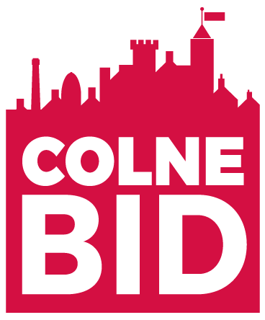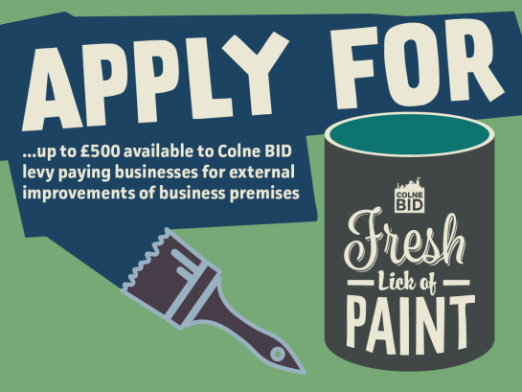
FRESH LICK OF PAINT APPLICATION FORM 2021 /2022
Colne BID Fresh Lick of Paint –a Shop front improvement grant of up to £500 is available to Colne BID levy paying businesses for improvements to the shop/business frontage – visible to public. Colne BID could issue a grant of up to £500 or half the cost of the external redecoration, whichever is lower, as a grant. The business is expected to contribute at least 50%. For example, on improvement costs of £1000, up to £500 would be paid by Colne BID and £500 by the business. In the case of over subscription, applications will be assessed by Colne BID board. Applications will be assessed on positive enhancements to businesses located in Colne BID area, contributing to the ‘attractiveness’ of the BID area under the ‘pride’ business plan objective.
PLEASE COMPLETE ALL FIELDS BELOW – ALL EVIDENCE REQUIRED MUST BE ATTACHED. FAILURE TO COMPLY WILL MEAN THE GRANT APPLICATION WILL NOT BE CONSIDERED.
NAME OF APPLICANT
CONTACT TEL NO.
EMAIL ADDRESS
NAME OF BUSINESS
ADDRESS OF BUSINESS
BID LEVY PAID FOR 2021/22?
TOTAL COST OF IMPROVEMENT
AMOUNT OF GRANT APPLIED FOR
BRIEF DESCRIPTION OF IMPROVEMENT TO BE MADE

- HAVE YOU ATTACHED YOUR QUOTE FOR WORK? Y / N
- HAVE YOU ATTACHED A ‘BEFORE’ PHOTO OF AREA TO BE IMPROVED? Y / N
- HAVE YOU APPLIED FOR OR RECEIVED A PREMISES IMPROVEMENT GRANT FROM PENDLE BOROUGH COUNCIL OVER THE LAST 3 YEARS Y/N (If YES – please outline details below)
____________________________________________________________
____________________________________________________________
I UNDERSTAND THAT PHOTOGRAPHIC EVIDENCE OF THE IMPROVEMENT (BEFORE AND AFTER) WILL BE REQUIRED BEFORE PAYMENT IS RELEASED.
I AGREE THAT THE GRANT WILL ONLY BE USED FOR IMPROVEMENT TO AN AREA ON MY BUILDING. THIS MAY INCLUDE CANOPY, SIGNAGE, PAINT, DECORATING COSTS.
I AGREE THAT THE SHOP FRONT IS VISIBLE TO THE PUBLIC & I HAVE GAINED ANY NECESSARY PLANNING CONSENT & ADHERES TO THE CONSERVATION AREA GUIDELINES (FOR BUSINESSES IN THE CONSERVATION AREA).
I AGREE TO ALLOWING COLNE BID TO USE INFORMATION RELATING TO THE FRESH LICK OF PAINT GRANT IN THEIR MARKETING, PR, WEBSITE/SOCIAL MEDIA ETC.

SIGNED.………………………………………………………………..……………….. DATE………………….……………………………
PLEASE RETURN TO: COLNE BID C/O Coversure Insurance, 50 Market Street, Colne, BB8 0HS
OFFICE USE ONLY:
All fields completed Y / N Accepted Y / N Amount granted £
All evidence attached Y / N Rejected Y / N Completion photo received Y / N
Grant paid - date
Criteria met: Y / N
Reason if rejected:

BID levy paid Y / N rejected

