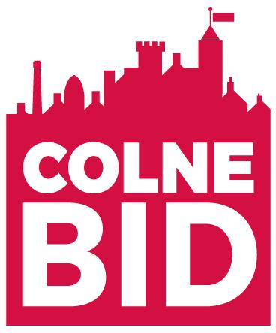
Hair and Beauty Group Meeting Minutes
Date: Monday 21st February
Time: 11am
Venue: Tubbs of Colne
Attendees: Aneesa McGladdery, Jane Turner, Paul McGladdery, Ian Stansfield, Krystina, Rebecca Louise, Susan Shaw

Aneesa opened the meeting and introduced everyone to one another and explained the purpose of the meeting. Aneesa opened by saying that the BID would like to work with the H&B businesses more, the BID sees these businesses as ambassadors of our town given the number of clients they see and how much time they spend with them on a 1 to 1 basis. The BID feel that if they communicate with them more, the word will get out about goings-on in the town, new businesses, and events.

Ian then spoke about his feelings about the BID, he feels that he doesn’t receive any benefits to his business from the BID and that the way it was delivered at beginning wasn’t right due to lack of communication and he felt that the BID had been pushed onto them. Given that their books are full and with a loyal customer base there wasn’t a good understanding of what the BID can do for the hair and beauty businesses in the town overall. Jane responded by saying that having a BID in place we are here to ensure that the town is always thriving, the high street stays a vibrant place to do business and we work to keep empty units minimal with a diverse range of businesses. Aneesa explained that we are also able to apply for funds that most councils can’t therefore bringing more investment into the town. Aneesa also said that we can bridge the gap between the businesses and the council on their behalf and gave examples where we helped in the town. A few felt that the BID did not include them in the marketing of the town on social media and the map- Aneesa explained that it can be difficult to include everyone in a small campaign and that an interactive digital map is being created currently to help minimise the errors and ensure that everyone sees some exposure.

This opened up more conversations and ideas about how the BID can help these were:

- Pamper parking: many of the clients come to the town and use their free parking for the entirety of their appointment so they do not have time to pop into the shops – can we create a pass that ensures the parking attendant doesn’t begin the parking time until the appointment has passed – Aneesa to explore with PBC
- Bring back spotlight on the side streets on social media and #selfcaresunday
- Umbrella sky project: H&B businesses on the street can have umbrellas in the windows to tie in with the theme
- Rebecca advised that the EV charging is broken in front of Shackleton Hall, but the space can’t be used and the warden issues tickets.
- Krystina asked for support applying for a parking space on Derby Street
- Cigarette butts are an issue for some salons so this can be investigated with the street cleaning team

Once these were discussed, Kirsty from Salon Promotions spoke about their business and what they can offer the hairdressers in the town. Aneesa asked that Kirsty be the dedicated account manager for Colne rather than different people looking after certain salons, she agreed to do this. She also agreed to speak with her social media team about doing a workshop at the next meeting – learning how to film transitional videos like before and after and highly engaging content for certain products, how to’s etc.

We agreed for the next meeting to take place on Monday 25th April at 11am – venue TBC

<END>

